Types of PoE Switches
# Source: AI Source: Provided by: [Data Path: Persons Table -> ID Column: 1, Name_En Column: Motasem Essam] -> From: [ChatGPT] on [12/18/2025]
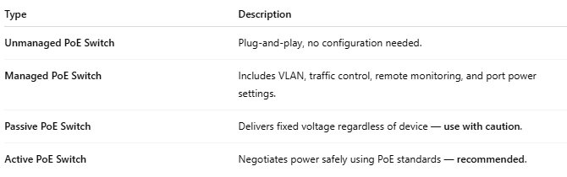
Type | Description
Unmanaged PoE Switch | Plug-and-play, no configuration needed.
Managed PoE Switch | Includes VLAN, traffic control, remote monitoring, and port power settings.
Passive PoE Switch | Delivers fixed voltage regardless of device — use with caution.
Active PoE Switch | Negotiates power safely using PoE standards — recommended.

